List of things added in Project:

1. Springboot with JPA

2. Swagger

3. Tested all the CRUD operations on Postman in Local

4. Added Spring Security for Authentication and Authorization

5. Added Redis Cache

6. Added JUnit

7. Created a maven build

8. Configured Logger

9. Created a MySql database.

10. Created AWS- RDS and added data to its DB instance.

11. Created Beanstalk application environment and deployed the application successfully.

12. Created Elastic cache –Redis in AWS.

13. Amazon S3 bucket

14. Created Eureka Client

15. SonarQube for code quality

1. Created Springboot starter Project

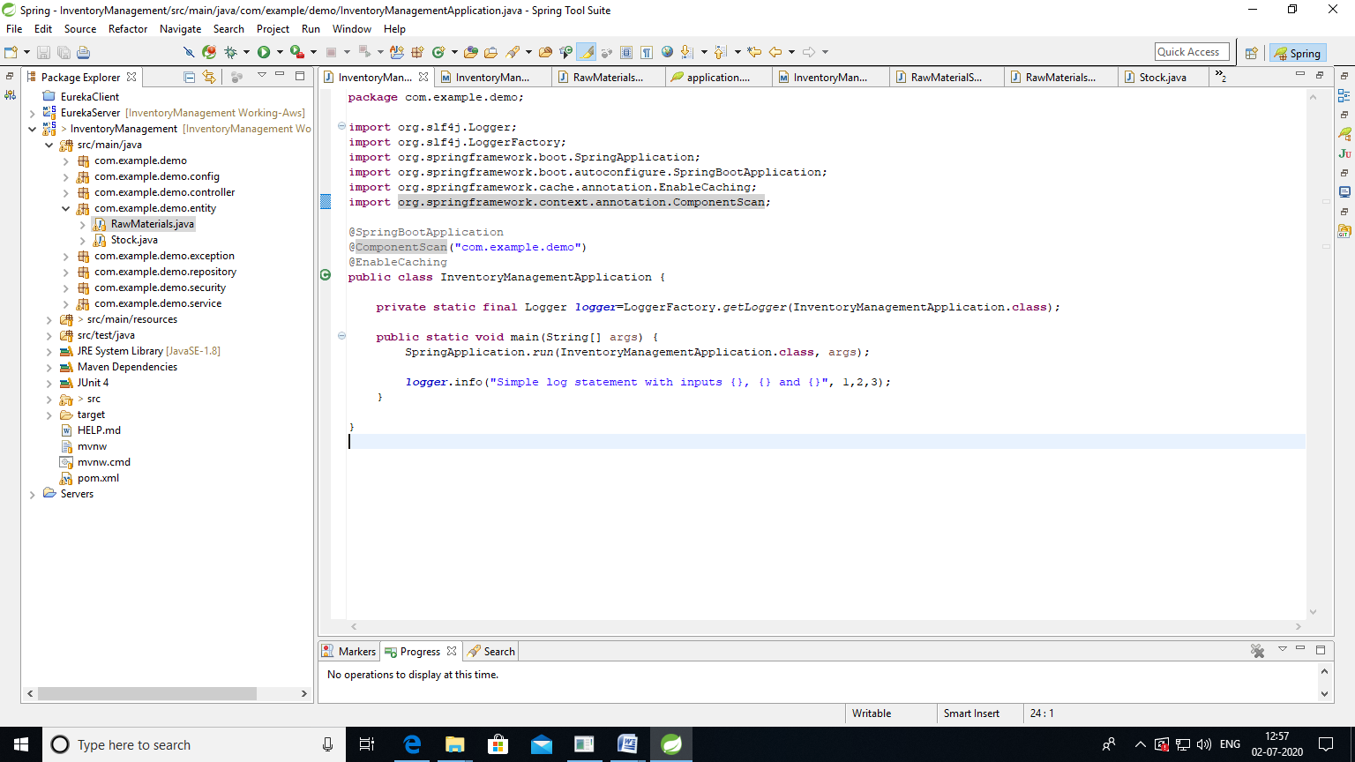

Added Entity bean:

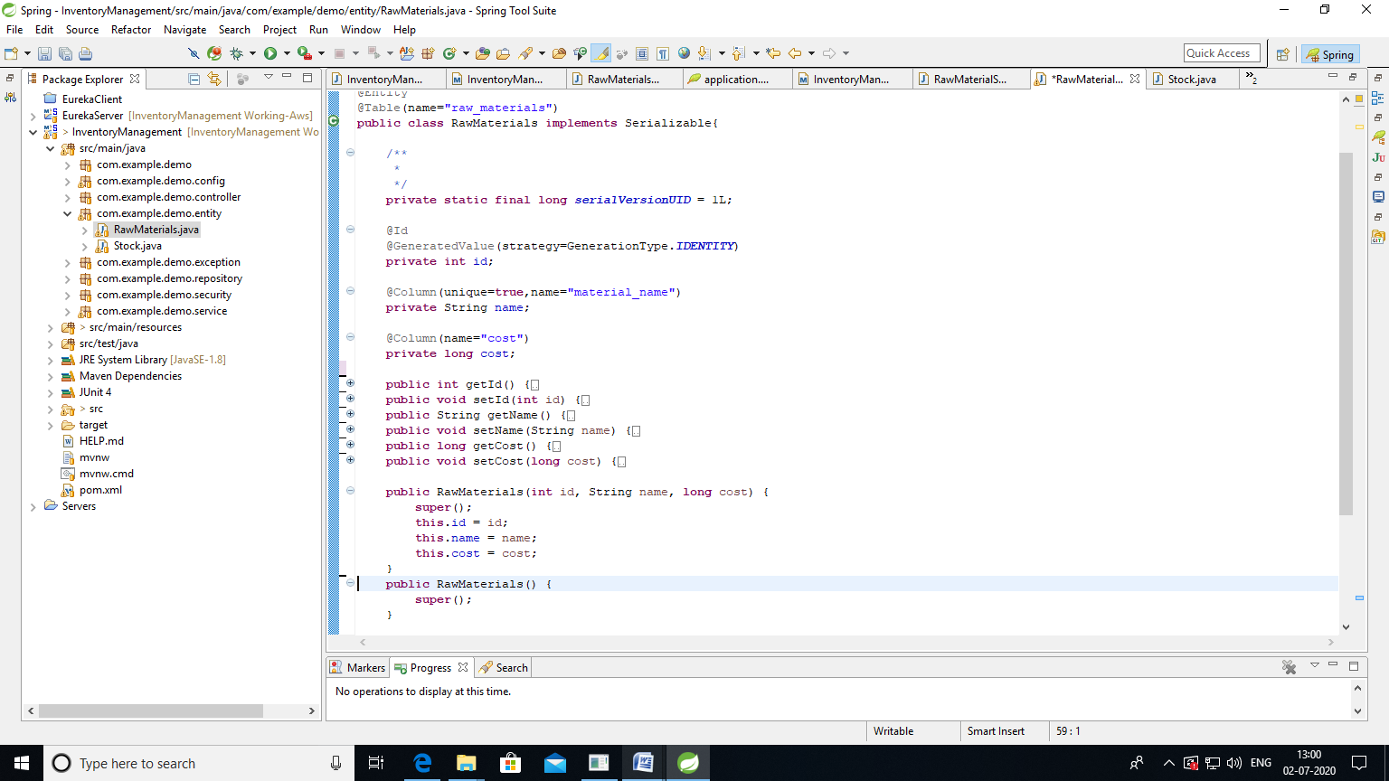

Created repository:

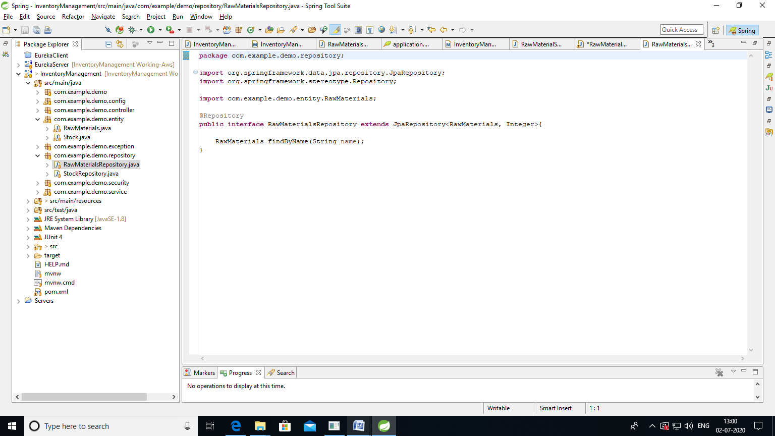

Created Service:

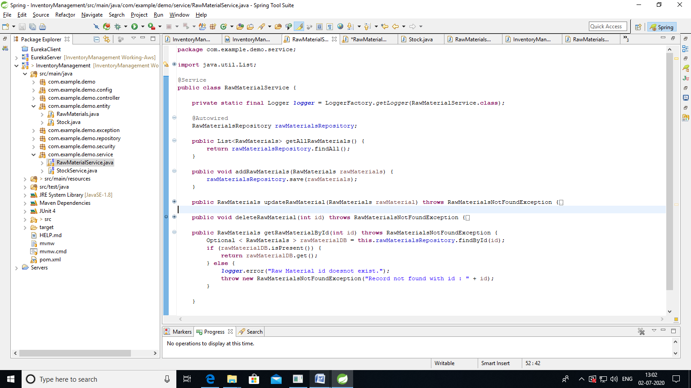

Created controller:

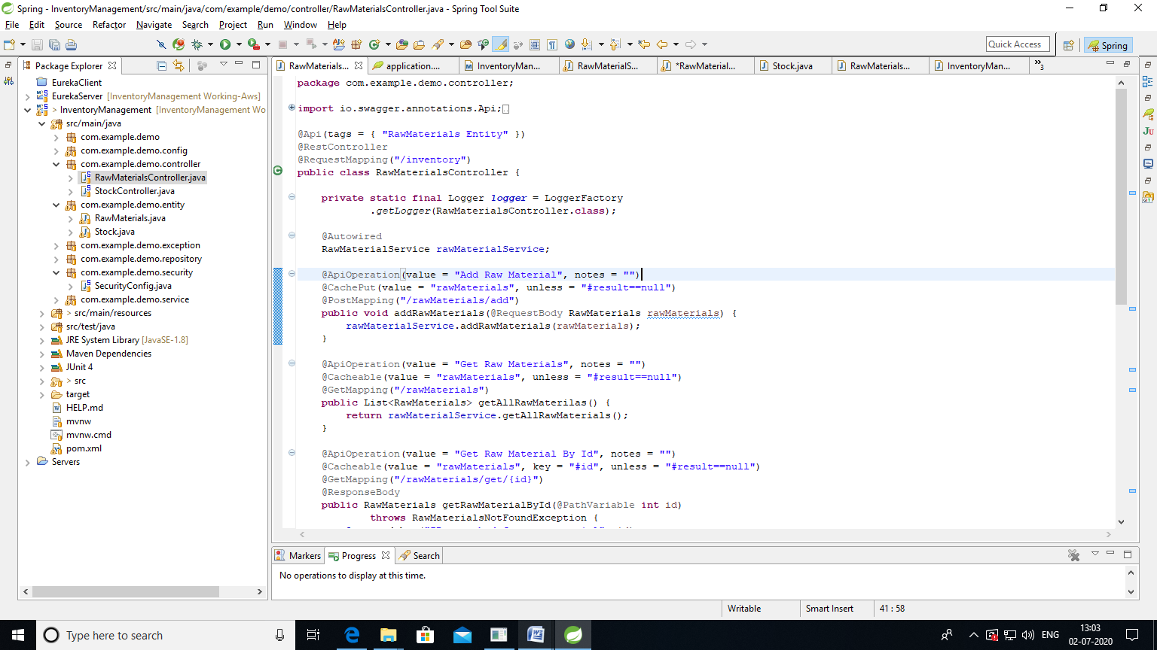

Created application.properties

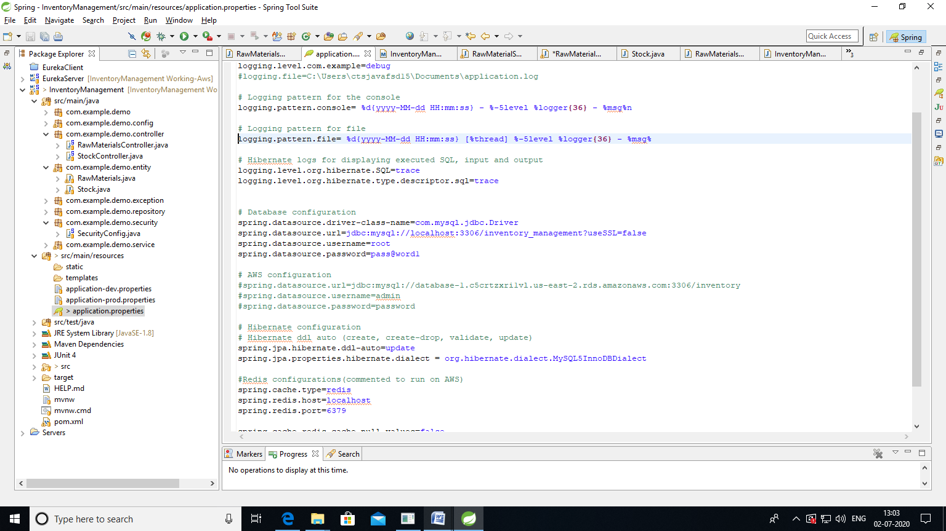

2. Swagger configuration

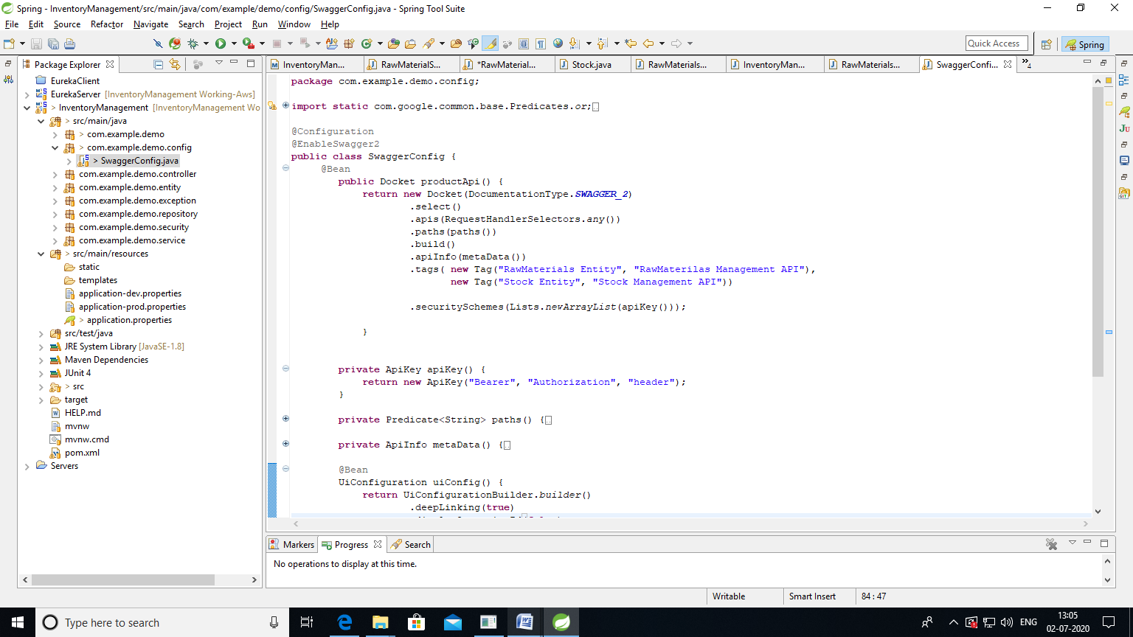

3. Postman fetching values with basic authentication

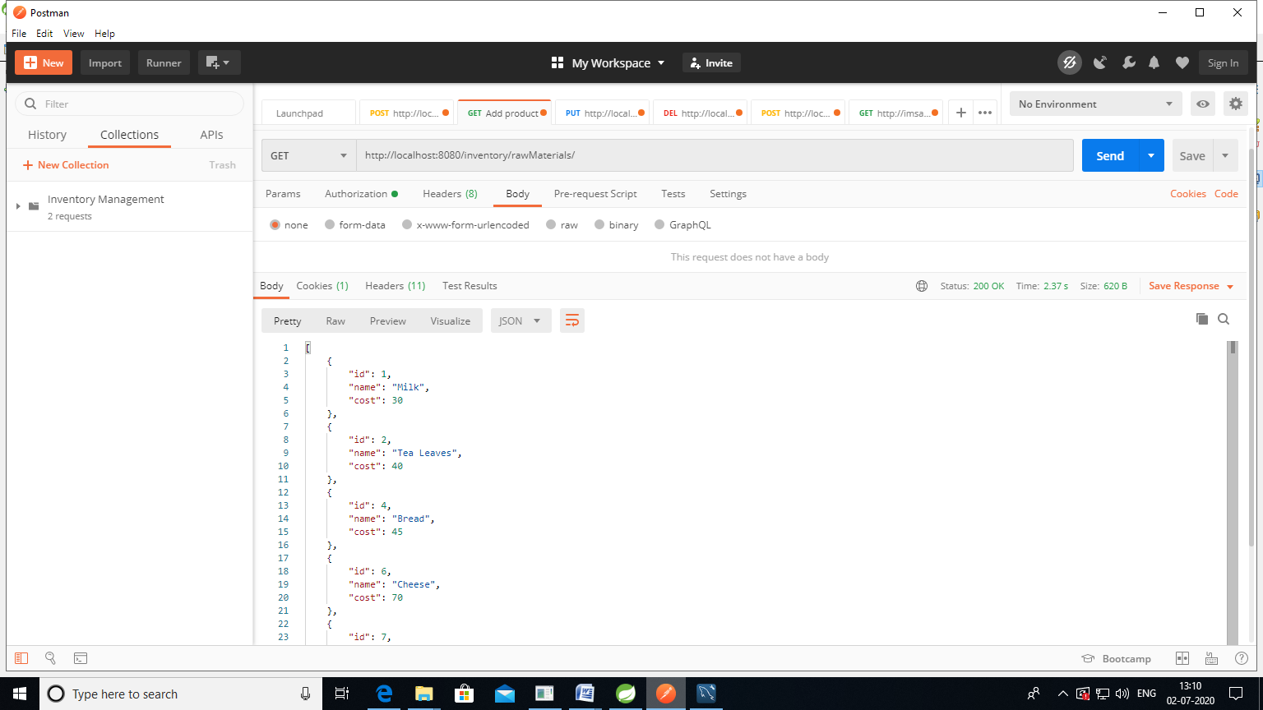

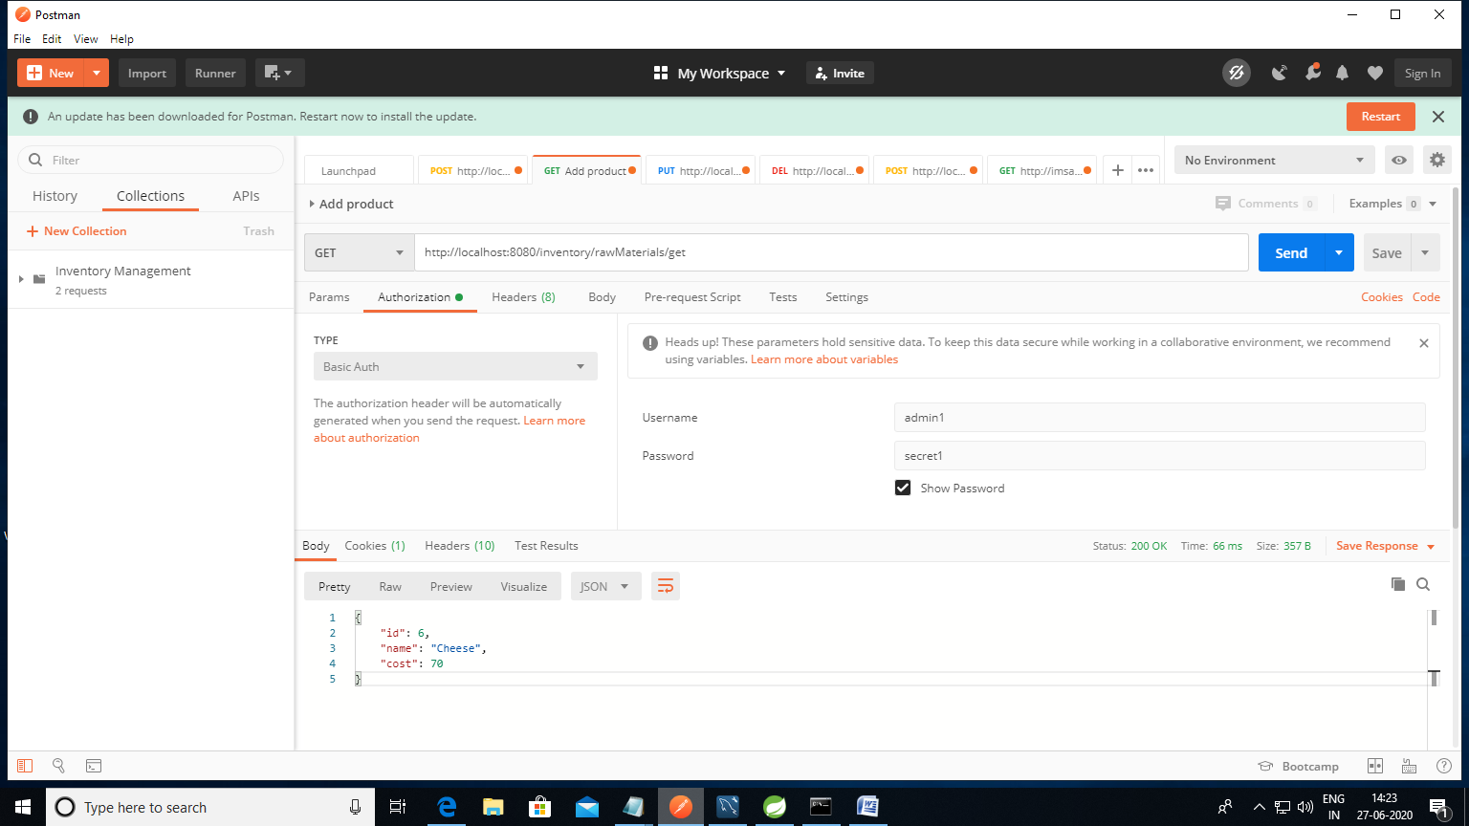

Logs displayed on console:

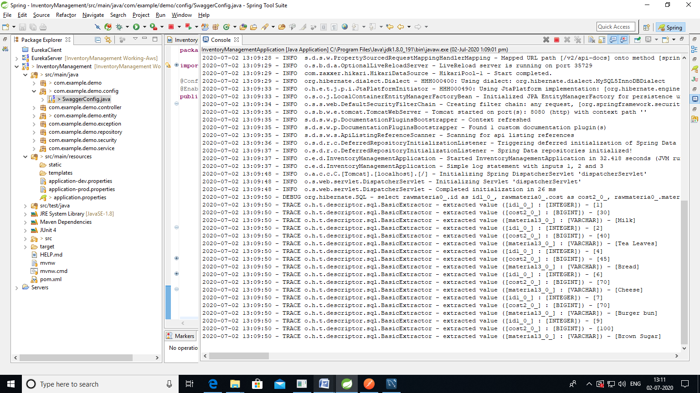

4. Spring security setup

Added dependency

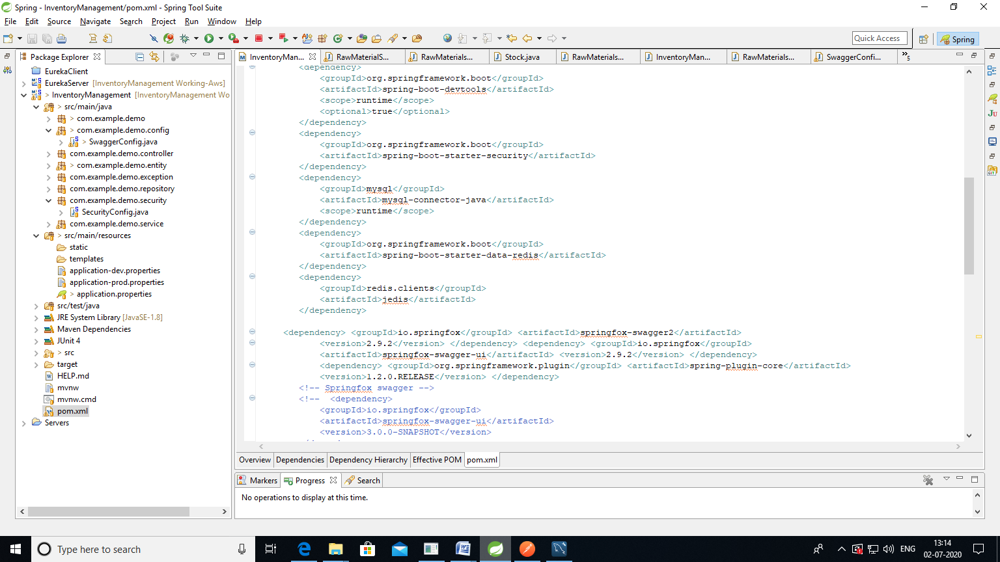

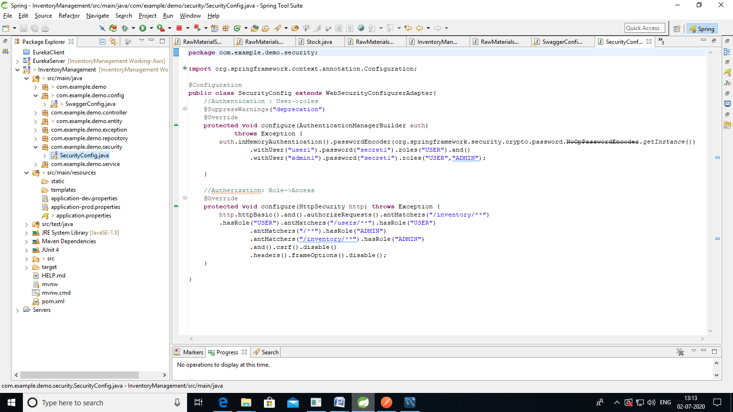

6. Redis Cache:

Configured redic cache server

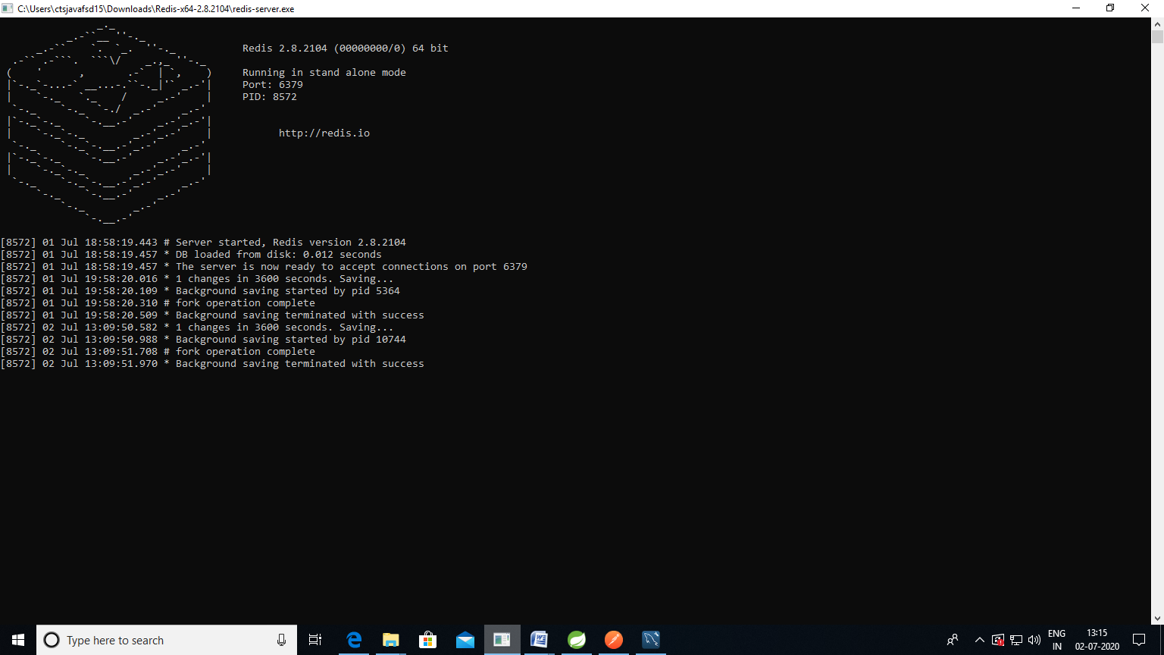

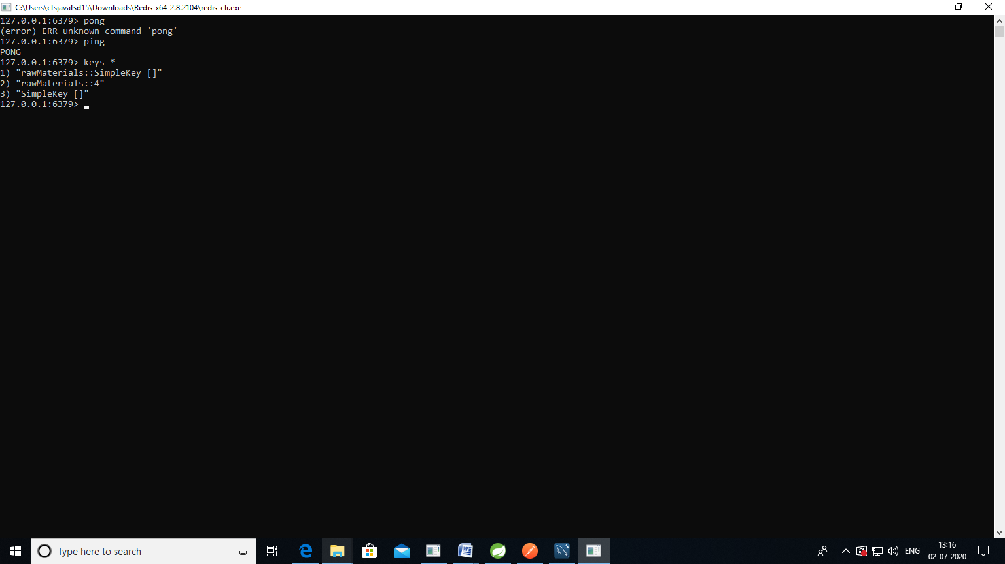

Added annotations in controller and main file @EnableCaching and @Cacheable @CacheEvict etc.

7. Added Junit

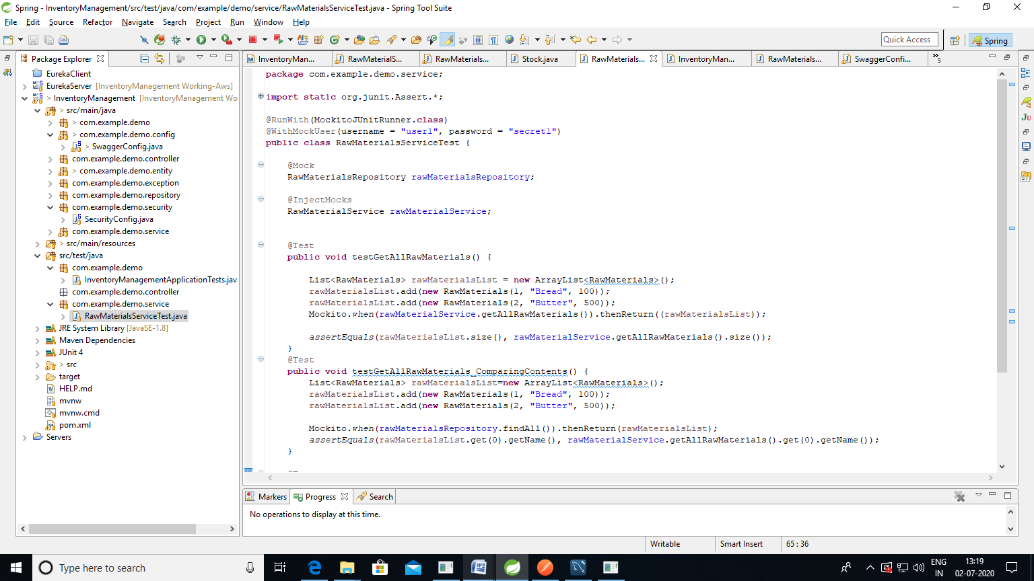

8. Created MySql DB

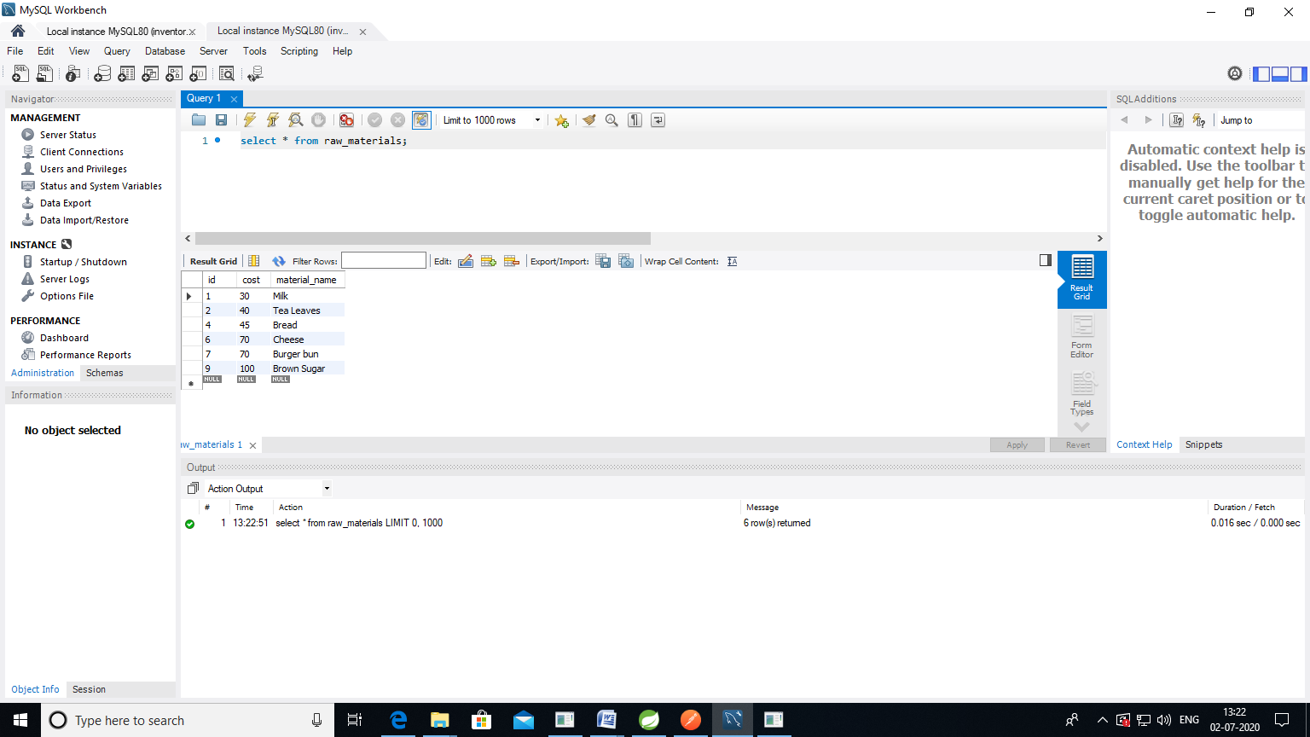

9.Aws RDS Database creation

<https://979427354379.signin.aws.amazon.com/console>

Create RDS DB on AWS.amazon.com

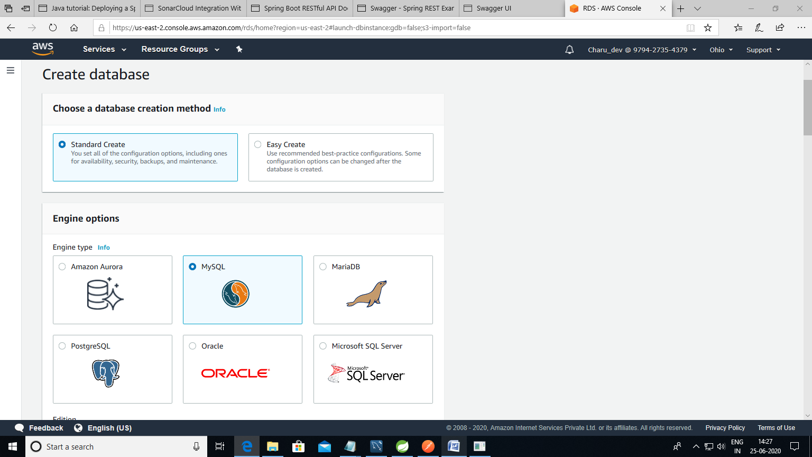

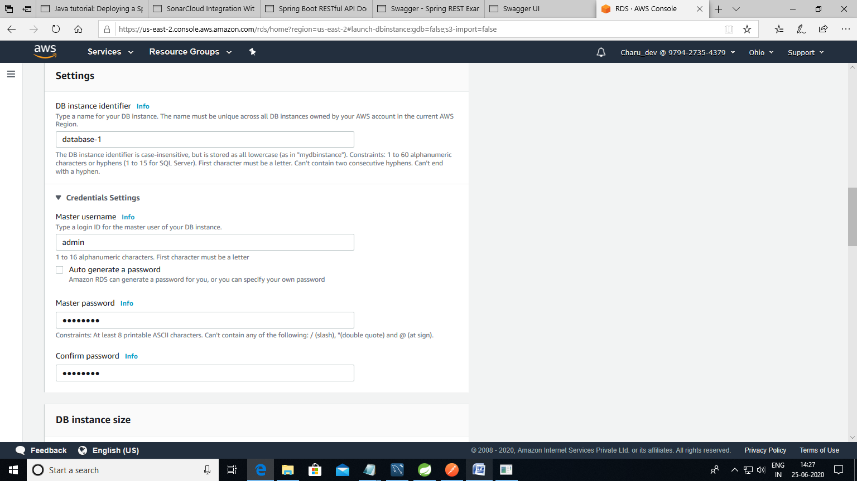

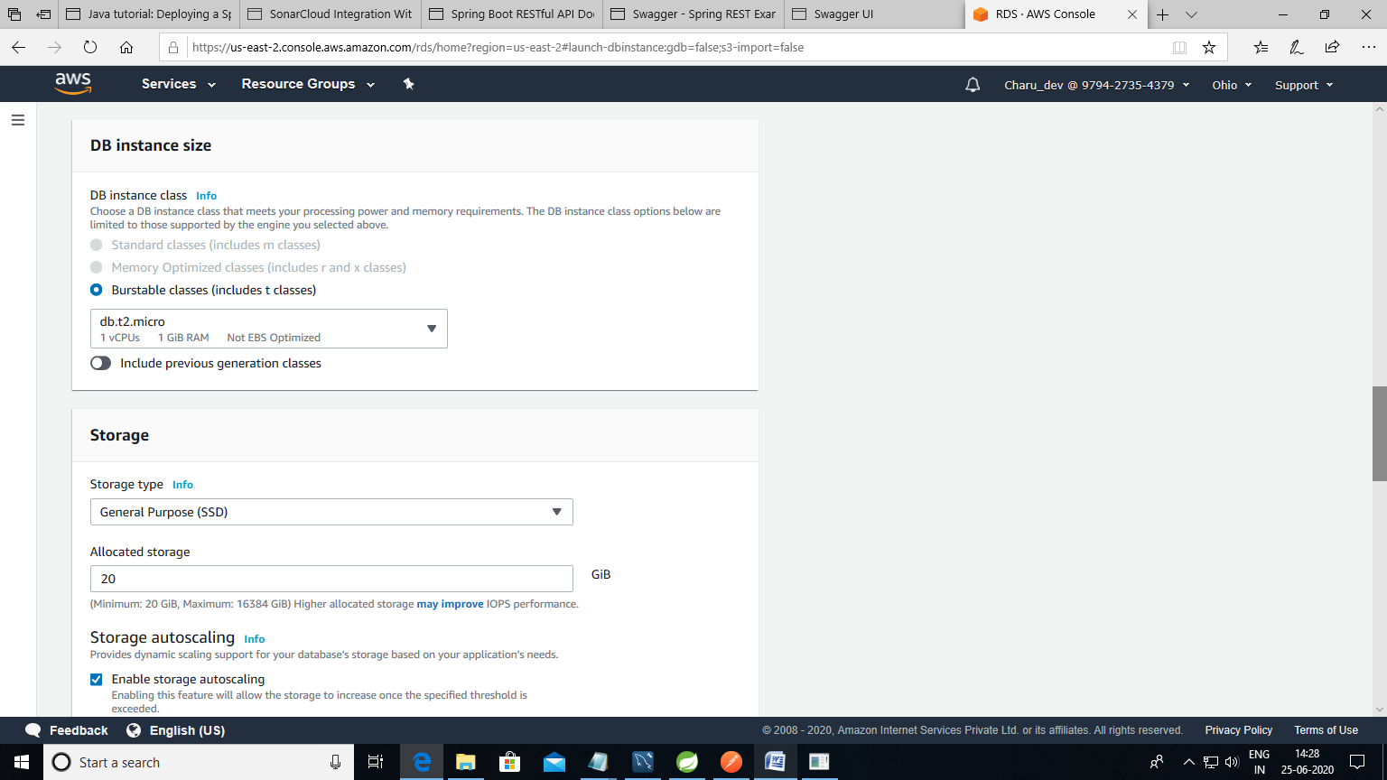

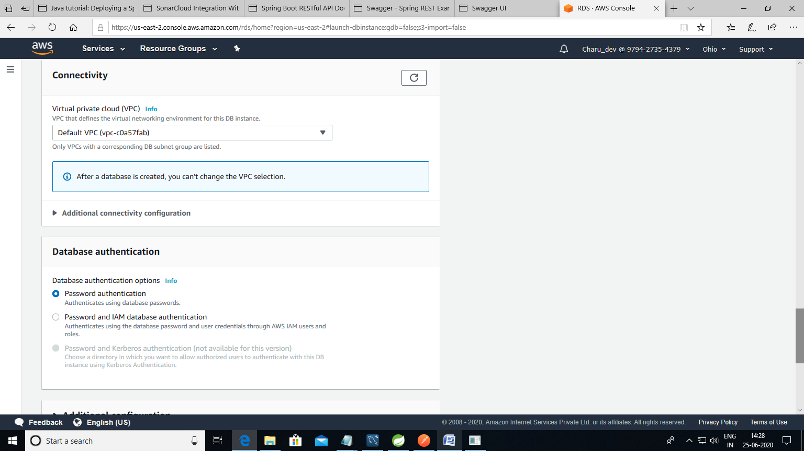

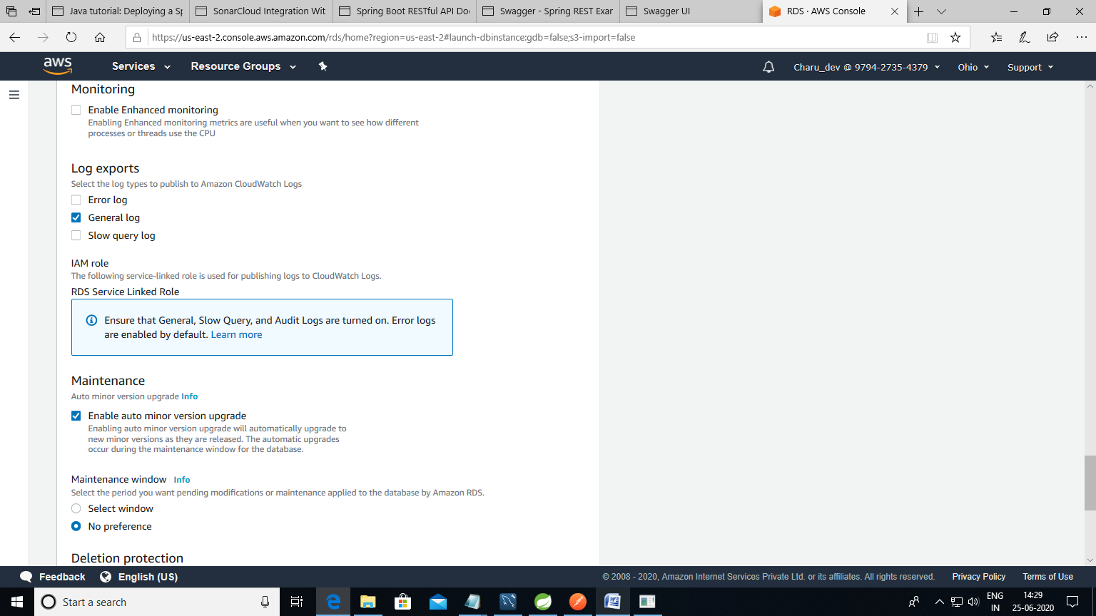

Database created successfully –database1

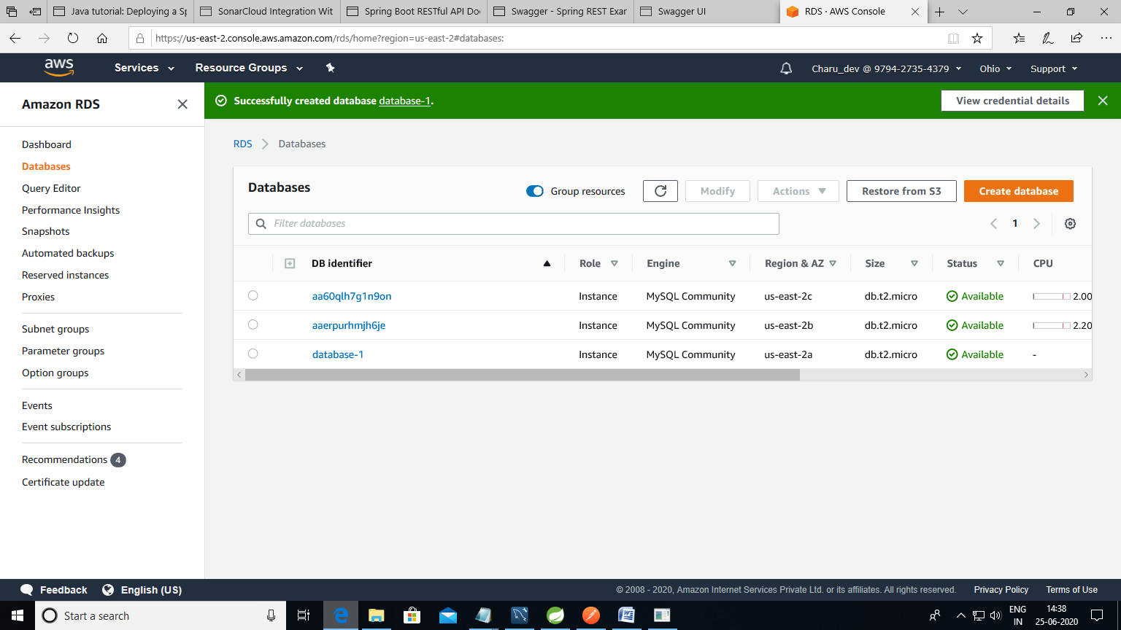

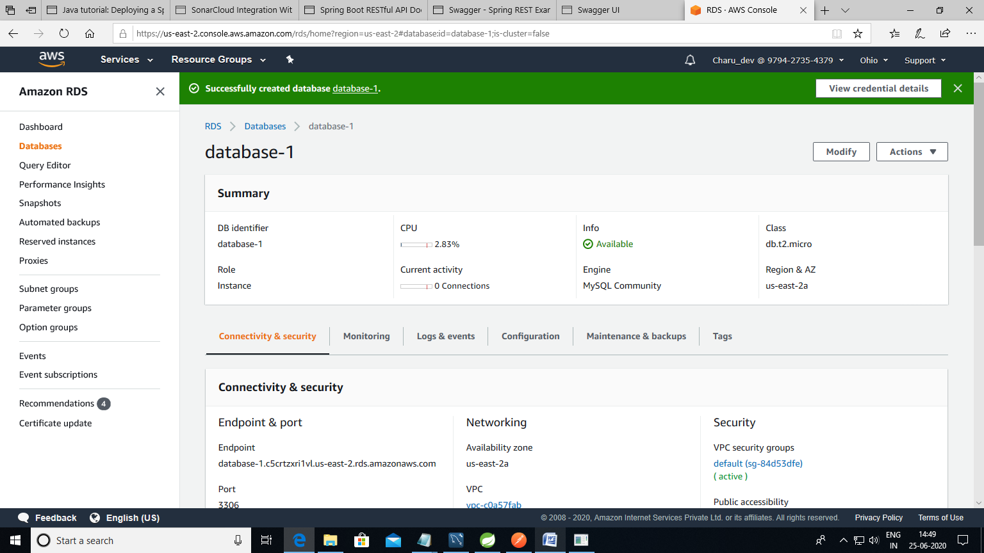

Amazon Beanstalk

Created application and deployed successfully

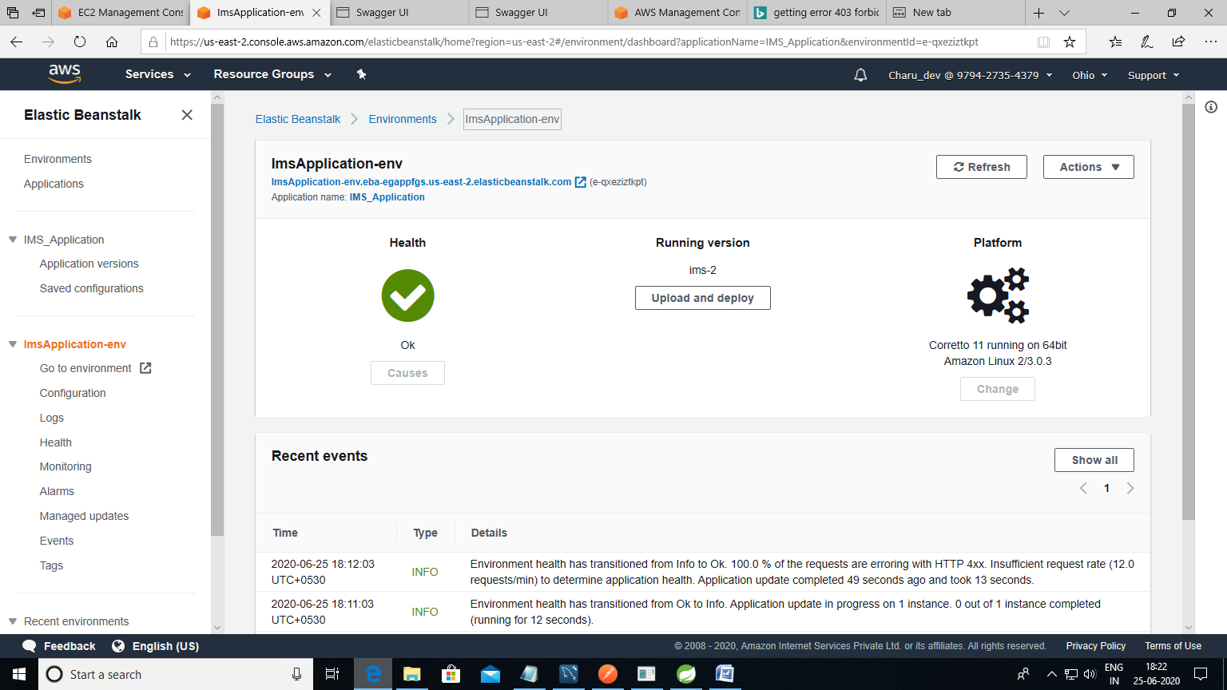

Link to access application:

imsapplication-env.eba-egappfgs.us-east-2.elasticbeanstalk.com/swagger-ui.html/

username: admin1

password: secret1

After logging in:

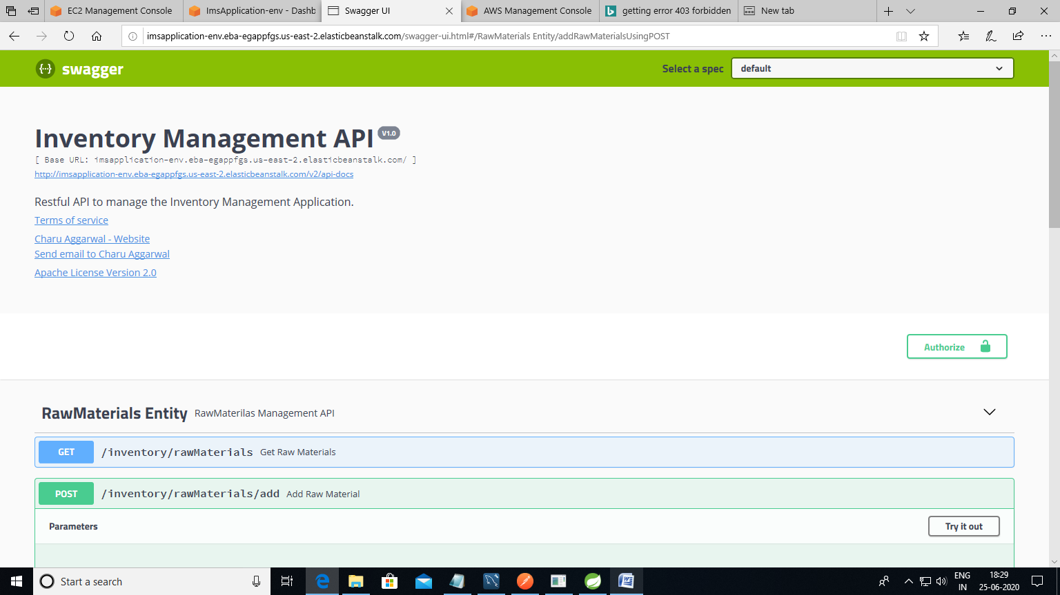

Added data into the Mysql table using swagger.

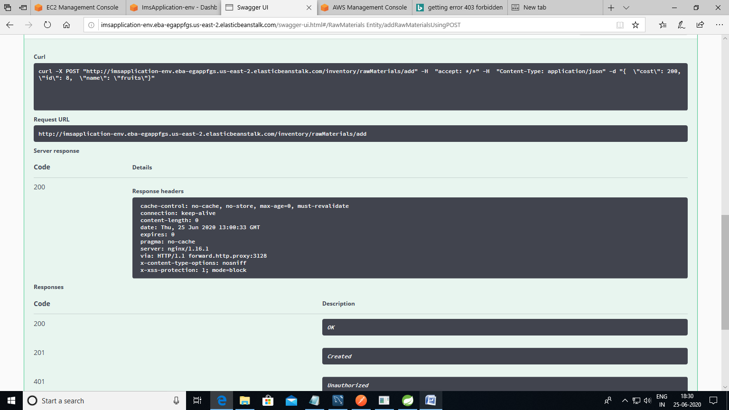

Values saved in database:

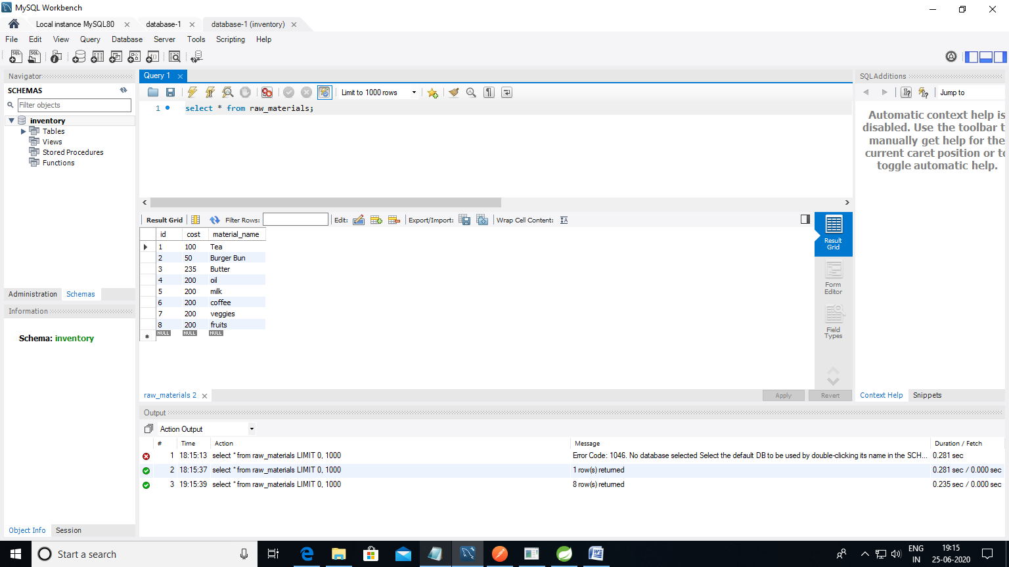

Redis cache in AWS:

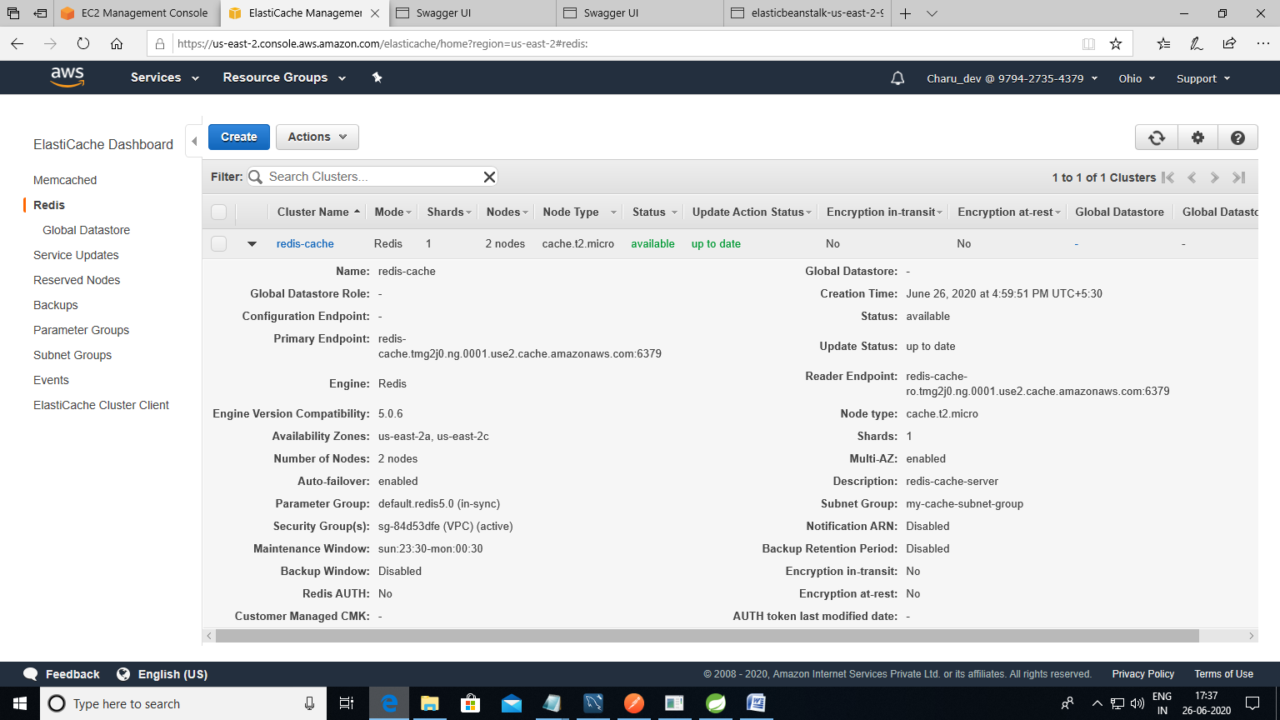

14.SonarQube:

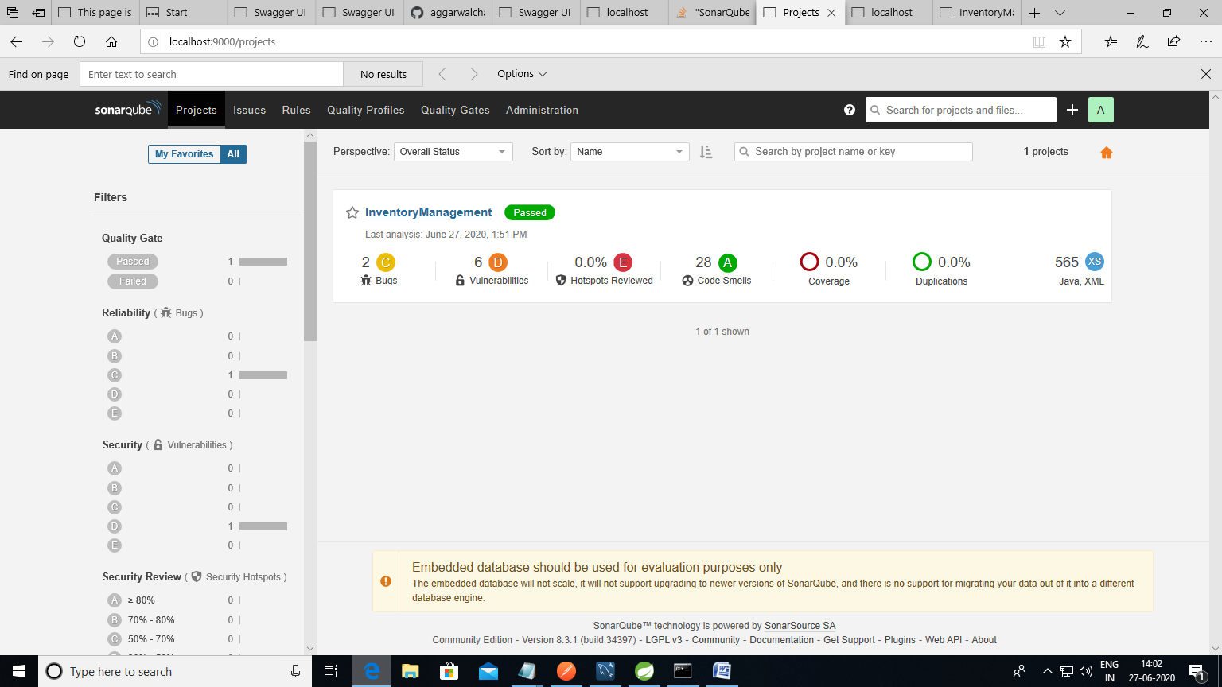

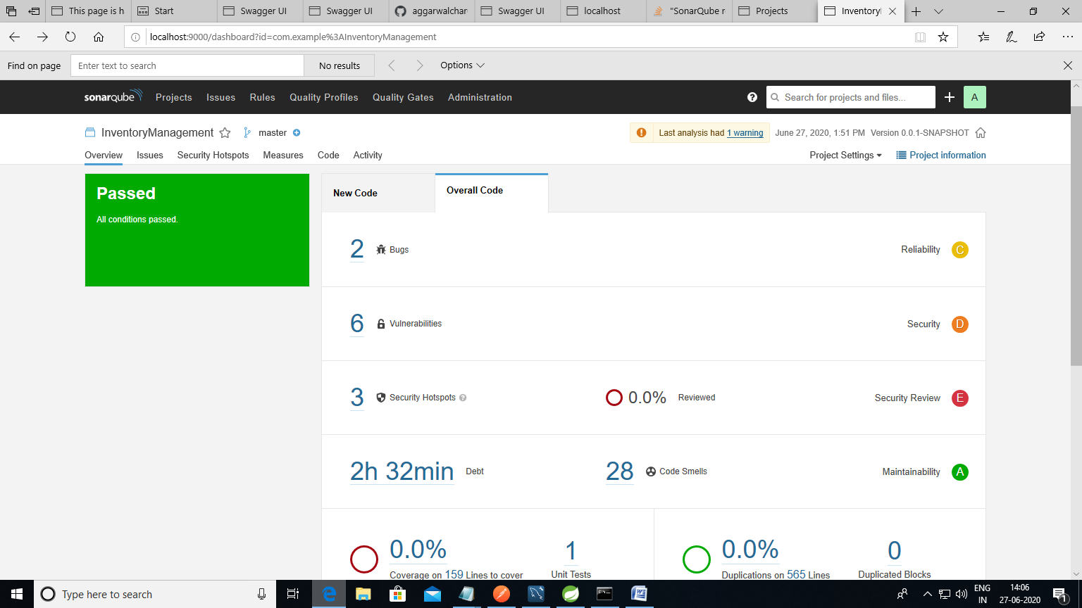

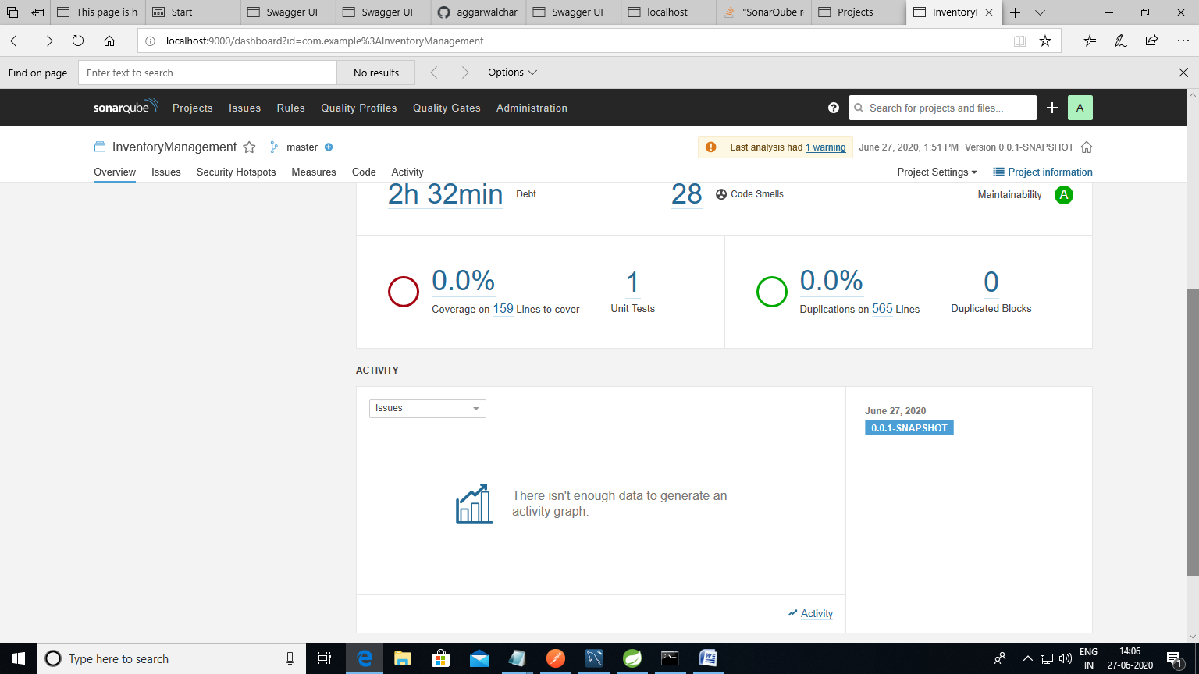

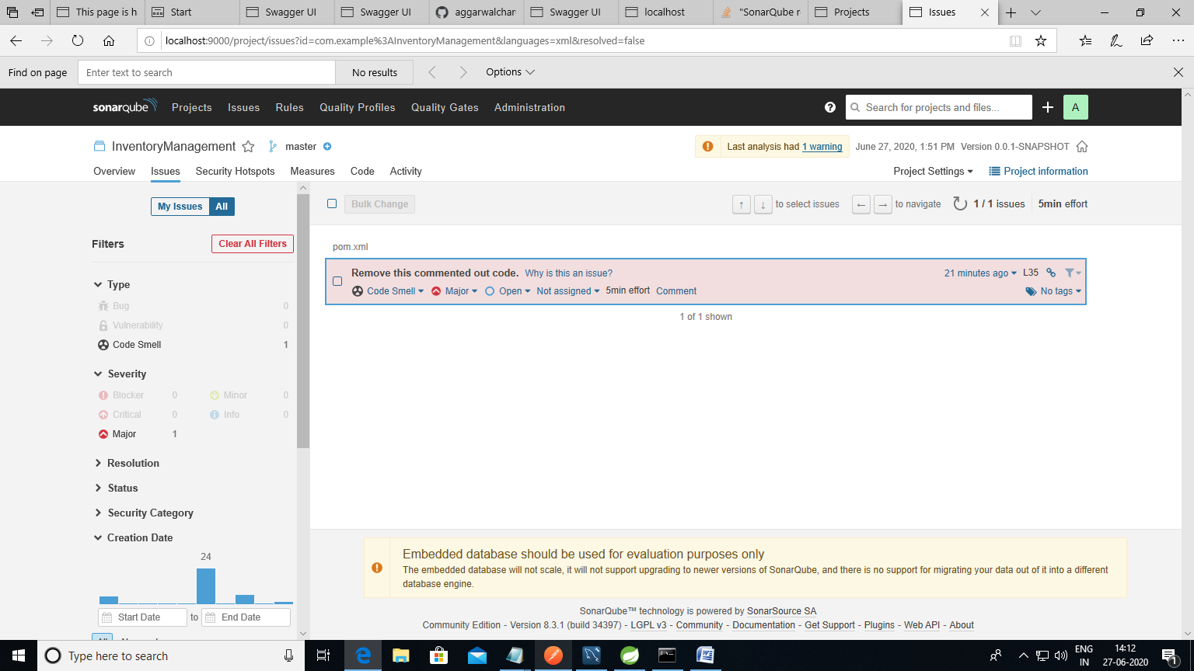

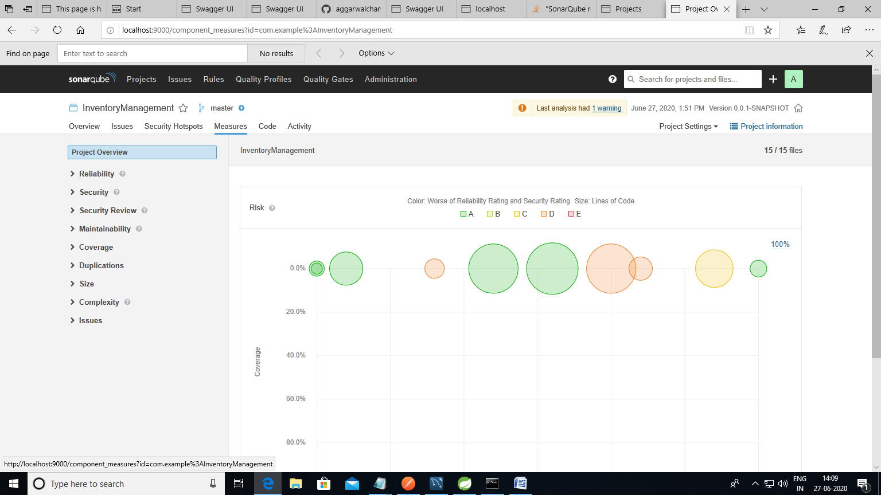

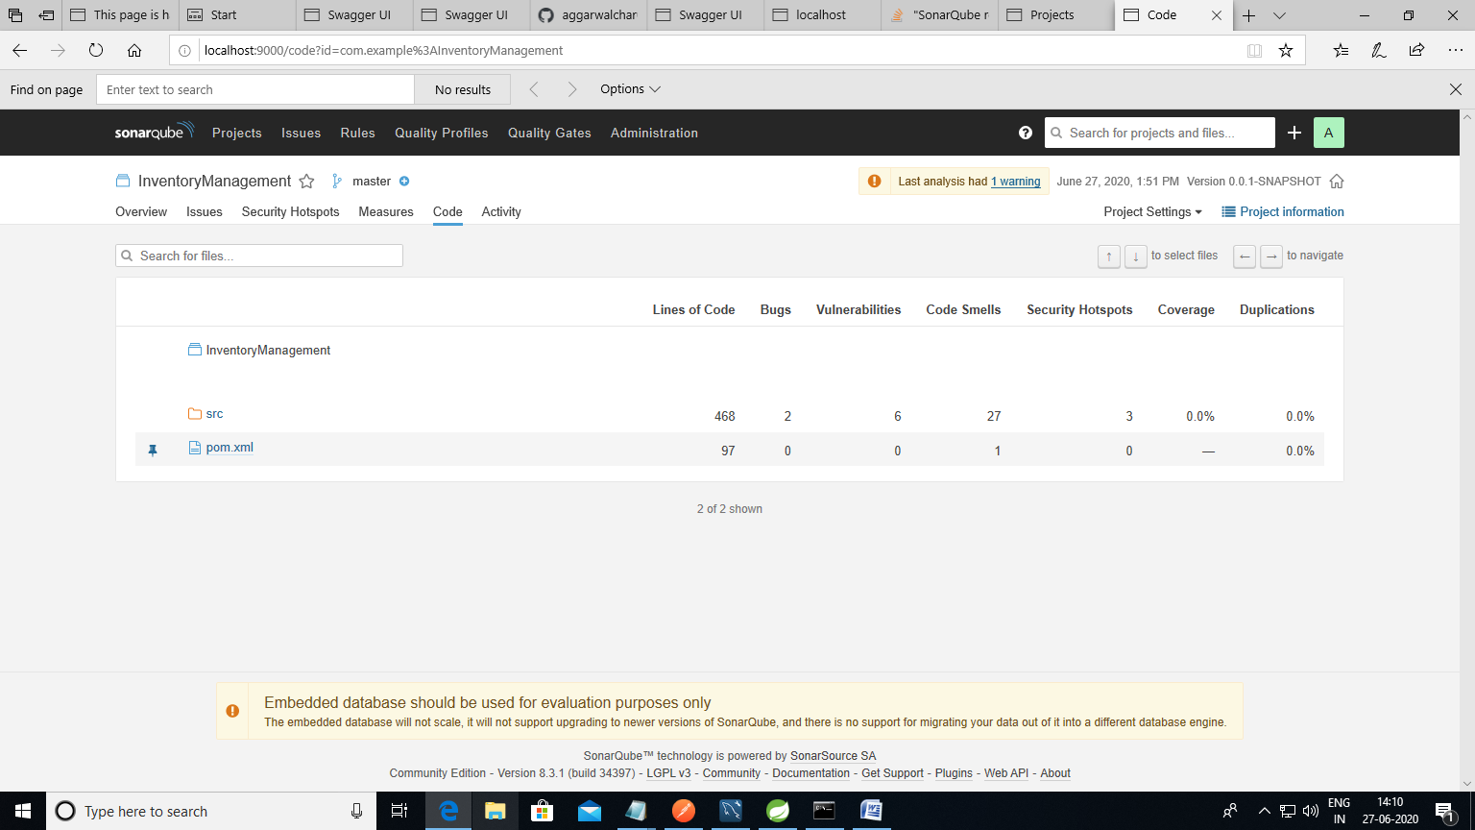

Github Link and details:

https://github.com/aggarwalcharu/InventoryManagement/

